**Software Requirement Specification**

**E-commerce project**

**Presented To: Dr.Mohamed Ramadan**

**Name (Ets3waQ)**

**Submitted By:**

Youssif Mohamed Ahmed

Manal Sayed Ahmed

Sally Mohamed Mousa

**REVISION HISTORY**

| **Date** | **Author** | **Distributed to** | **Version** | **Description** |
| --- | --- | --- | --- | --- |
| 04/06/2024 | All | All | 1.0 | template |

**1 Introduction**

Our online clothing store offers a curated collection of fashionable apparel and accessories for men, women, and children. With a focus on quality, style, and affordability, we aim to provide customers with a seamless shopping experience from browsing to checkout.

**1.2 Scope**

**DFD :**

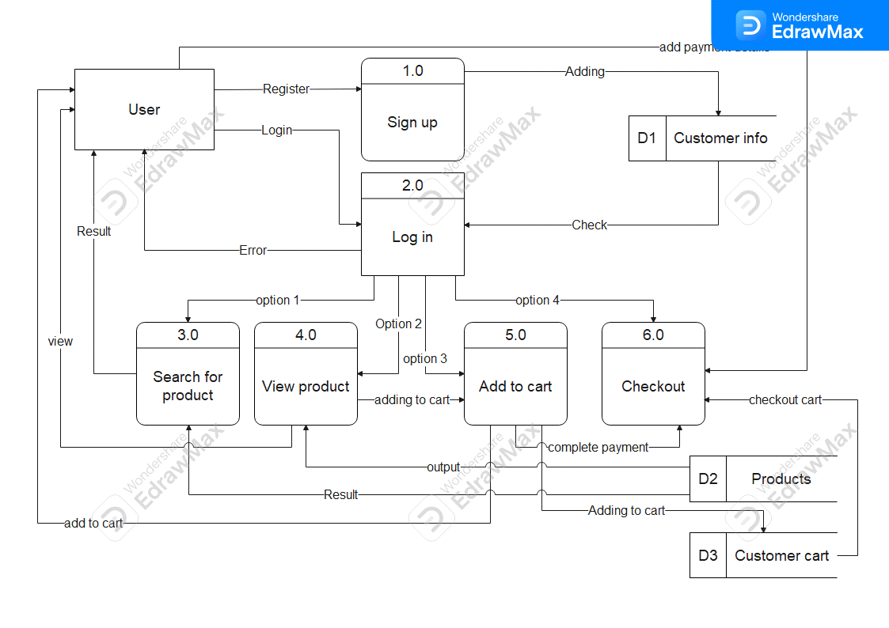

Context Diagram:

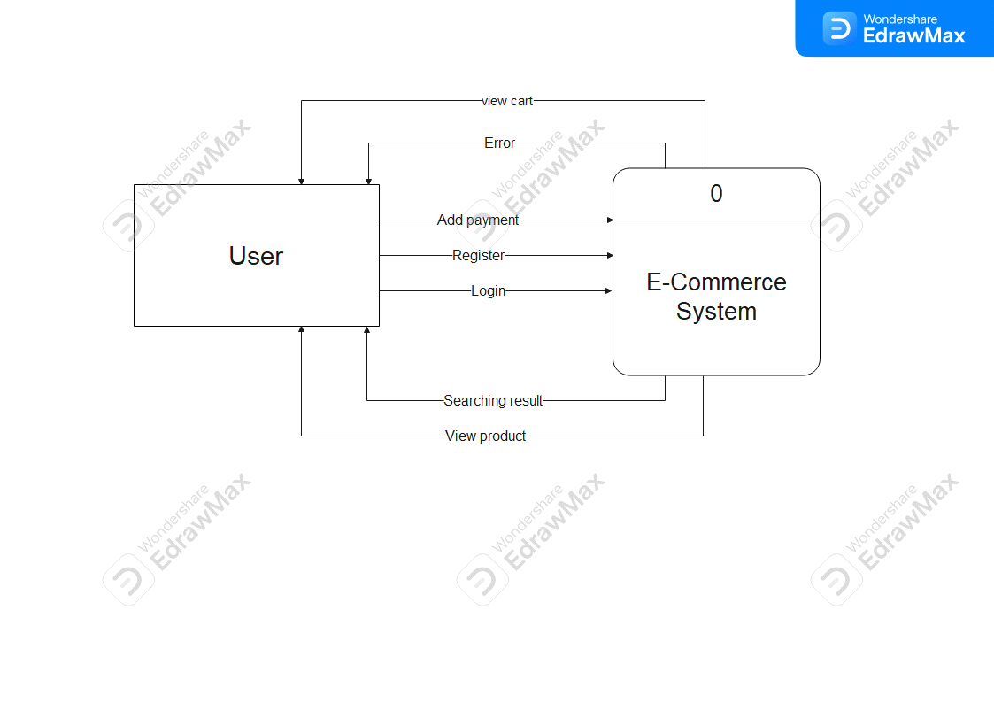

Use Case Diagram 1:

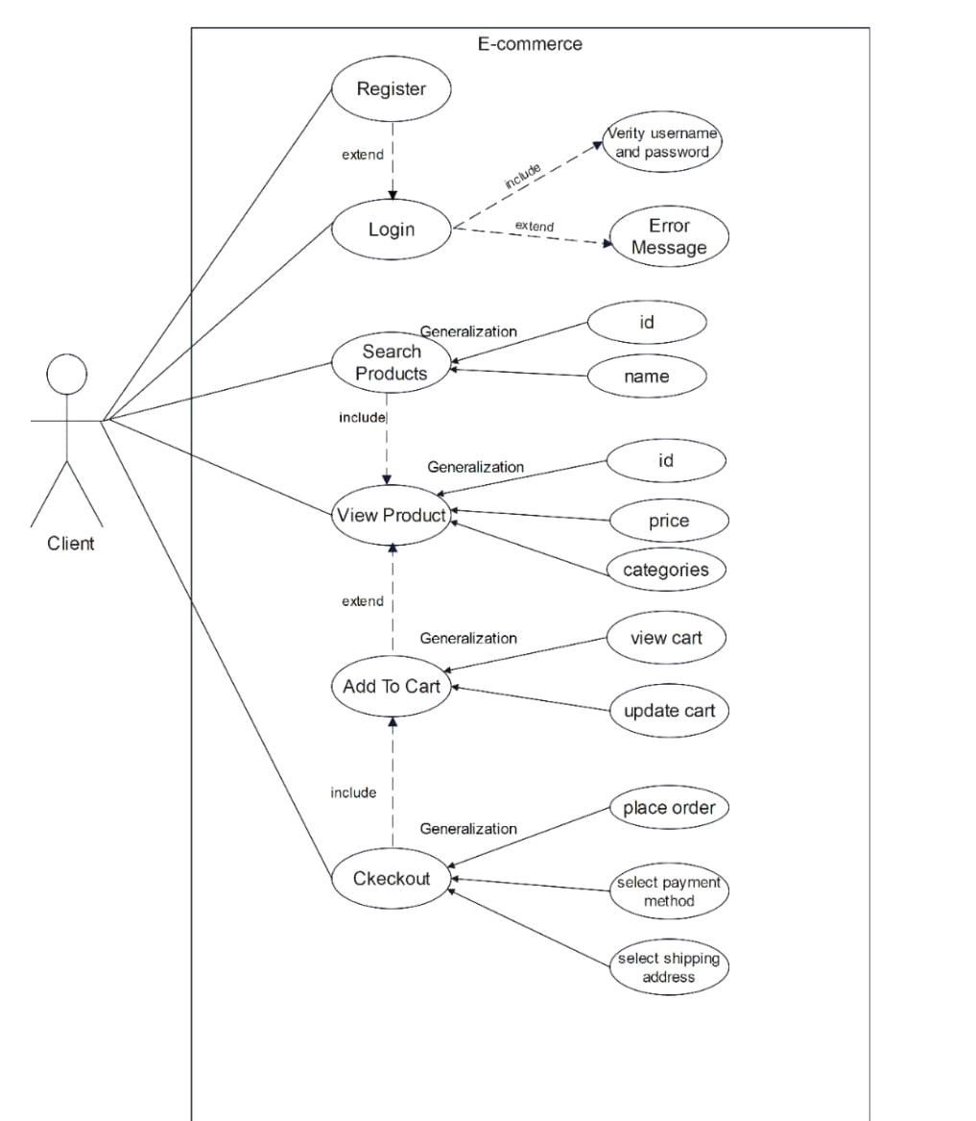

Use Case diagram 2:

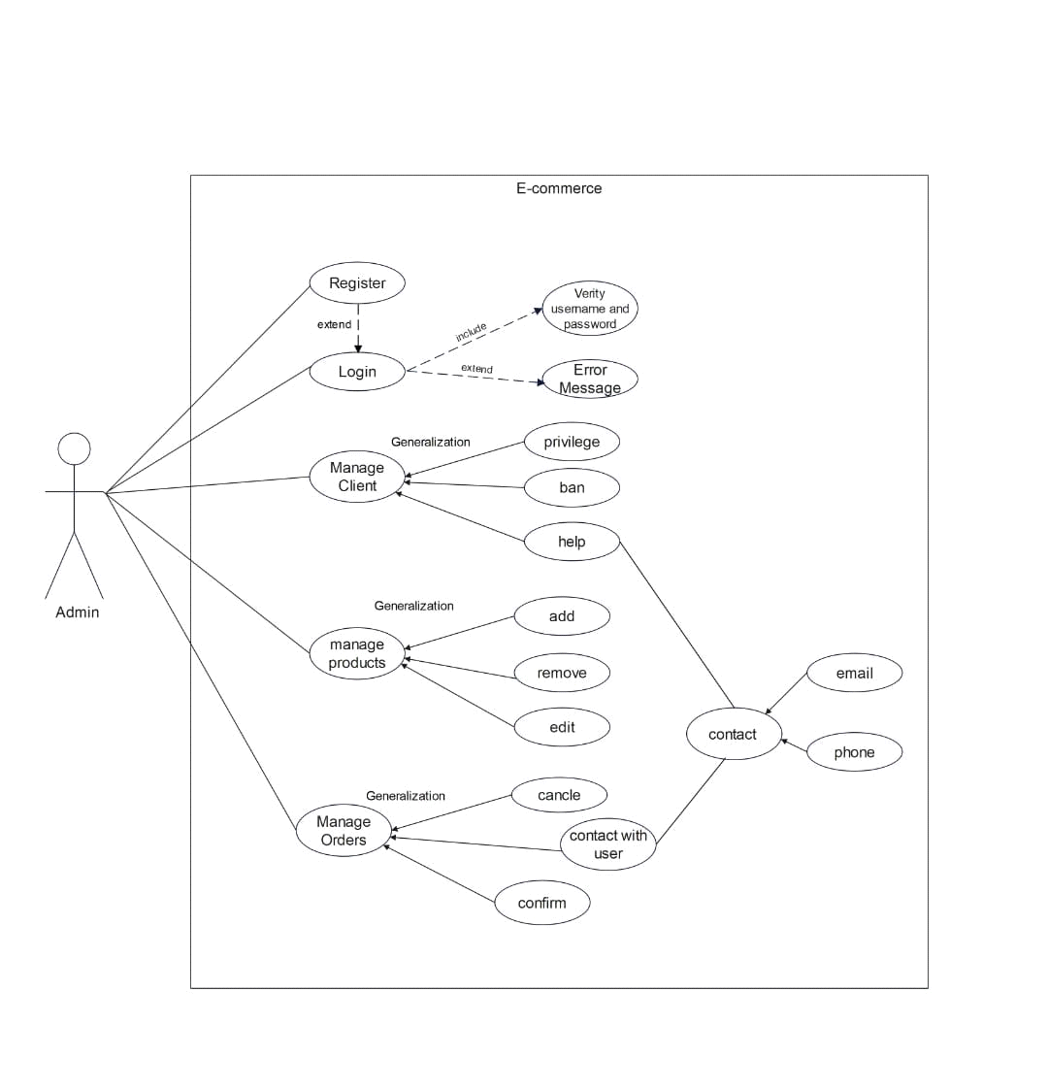

**Use case senario:**

| Name: Register | | ID:UC-01 | | |
| --- | --- | --- | --- | --- |
| Actor: New Client | | | | |
| Description:  -This use case outlines the process of a new client registering an account on the e-commerce platform. | | | | |
| Preconditions:  -The client is not currently registered on the e-commerce website. | | | | |
| Main Flow:  1. The client navigates to the registration page and clicks on the "Register" button.  2. The system presents a registration form, prompting the client to enter required information such as name, email address, and password.  3. The client fills out the registration form and submits the information.  4. The system validates the provided information, checks for unique email addresses, and creates a new client account.  5. The system sends a verification email to the client's provided email address.  6. The client clicks on the verification link in the email to confirm their registration.  7. The system activates the client's account, and the client is redirected to the login page. | | | | |
| Alternative Flow:  - If the client enters an email address that is already registered:  1. The system displays an error message indicating that the email address is already associated with an existing account.  2. The client may choose to log in with the existing account or use a different email address for registration. | | | | |
| Postconditions:  The client has successfully registered for an account, and their account is now active. | | | | |
| Input | Source | | Output | Destination |
| - Client-provided information during the registration process. | - Client input through the registration form. | | - Verification email sent to the client's provided email address. | - Displayed on the client's device screen, and the verification email is sent to the client. |

| Name: Login | | ID:UC-02 | | |
| --- | --- | --- | --- | --- |
| Actor: Client | | | | |
| Description:  -This use case describes the process of a client logging into their account on the e-commerce website. | | | | |
| Preconditions:  -The client has registered an account on the e-commerce website. | | | | |
| Main Flow:  1. The client initiates the login process by clicking on the "Login" button on the website's homepage.  2. The system presents a login page with fields for the client to enter their username and password.  3. The client enters their username and password.  4. The client submits the login form.  5. The system verifies the client's credentials.  6. The system authenticates the client and grants access to their account.  7. The system redirects the client to their account dashboard or the home page, displaying personalized content and options. | | | | |
| Alternative Flow:  - Invalid Credentials:  1.The system detects that the entered credentials are invalid (incorrect username or password).  2.The system displays an error message indicating the invalid credentials.  3.The client is prompted to re-enter the correct credentials. | | | | |
| Postconditions:  - The client is successfully logged into their account and gains access to personalized features. | | | | |
| Input | Source | | Output | Destination |
| - Client-provided email address and password during the login | - Client input through the login form. | | - Successful login redirects the client to their account or home | - Displayed on the client's device screen. |

| Name: Search Products | | ID:UC-03 | | |
| --- | --- | --- | --- | --- |
| Actor: Client | | | | |
| Description:  -This use case describes the process of a registered client searching for products on the e-commerce platform . | | | | |
| Preconditions:  -The Client is logged in to the e-commerce website. | | | | |
| Main Flow:  1. The client navigates to the search bar on the e-commerce website.  2. Enters the desired keywords or product name.  3. The system retrieves relevant products based on the search query.  4. Displays a list of matching products with brief details. | | | | |
| Alternative Flow:  - If the search query yields no results:  1. The system displays a message indicating no matching products found.  2. The client may refine the search criteria and repeat the process. | | | | |
| Postconditions:  The client sees a list of products matching the search criteria. | | | | |
| Input | Source | | Output | Destination |
| - Client-provided search query. | - Client input through the website interface. | | - List of products matching the search criteria. | - Displayed on the client's device screen. |

| Name: View Products | | ID:UC-04 | | |
| --- | --- | --- | --- | --- |
| Actor: Client | | | | |
| Description:  -This use case outlines the process of a registered client viewing detailed information about a specific product on the e-commerce platform. | | | | |
| Preconditions:  -The client is logged in to the e-commerce website and has navigated to a product page. | | | | |
| Main Flow:  1. The client selects a product category or clicks on a specific product.  2. The system displays detailed information about the selected product, including images, price, description, and specifications.  3. The client can scroll through additional images and read client reviews.  4. The system provides options for the client to add the product to the shopping cart or proceed with the purchase. | | | | |
| Alternative Flow:  - If the client encounters an out-of-stock product:  1. The system displays a message indicating the product is currently unavailable.  2. The client may choose to explore similar products or return to the previous page. | | | | |
| Postconditions:  -The client has access to comprehensive details about the selected product. | | | | |
| Input | Source | | Output | Destination |
| - Client interaction with the product selection interface. | - Client input through the website interface. | | - Detailed information about the selected product, including images, price, description, and specifications. | - Displayed on the client's device screen. |

| Name: Add To Cart | | ID:UC-05 | | |
| --- | --- | --- | --- | --- |
| Actor: Client | | | | |
| Description:  -This use case describes the process of a registered client adding a product to their shopping cart on the e-commerce platform. | | | | |
| Preconditions:  -The client is logged in to the e-commerce website and has viewed details about a specific product. | | | | |
| Main Flow:  1. The client clicks the "Add to Cart" button on the product page.  2. The system adds the selected product to the client's shopping cart.  3. The system updates the cart icon to reflect the added item and shows the total number of items in the cart.  4. The client has the option to continue shopping or proceed to the checkout. | | | | |
| Alternative Flow:  - If the selected product is out of stock:  1. The system displays a message indicating that the product is currently unavailable.  2. The client may choose to remove the item from the cart or explore similar products. | | | | |
| Postconditions:  -The selected product is added to the client's shopping cart, and the cart reflects the updated contents. | | | | |
| Input | Source | | Output | Destination |
| - Client action of clicking the "Add to Cart" button. | - Client input through the website interface. | | - The shopping cart is updated to include the selected product, and the client sees a confirmation message. | - Displayed on the client's device screen, particularly in the shopping cart section. |

| Name: Checkout | | ID:UC-06 | | |
| --- | --- | --- | --- | --- |
| Actor: Client | | | | |
| Description:  -This use case outlines the process of a registered client completing the checkout to purchase the items in their shopping cart on the e-commerce platform. | | | | |
| Preconditions:  -The client is logged in to the e-commerce website and has added items to their shopping cart. | | | | |
| Main Flow:  1. The client navigates to the shopping cart and clicks on the "Checkout" button.  2. The system displays a summary of the items in the cart, including quantities and total price.  3. The client confirms their shipping address and selects a payment method.  4. The system prompts the client to review their order details, including shipping costs and taxes.  5. The client confirms the order and clicks the "Place Order" button.  6. The system processes the payment, updates the order status, and sends an order confirmation to the client 's email.  7. The client receives an order confirmation with details such as order number and estimated delivery date. | | | | |
| Alternative Flow:  - If the client 's payment method is declined:  1. The system displays an error message indicating the payment failure.  2. The client can update their payment information or choose an alternative payment method. | | | | |
| Postconditions:  - The client has successfully completed the checkout process, and the order is confirmed. | | | | |
| Input | Source | | Output | Destination |
| - Client input for shipping address, payment method, and order confirmation. | - Client input through the website interface. | | - Order confirmation, including order number and estimated delivery date. | - Displayed on the client's device screen, and a confirmation email is sent to the client. |

| Name: Admin Manage Client | | ID:UC-07 | | |
| --- | --- | --- | --- | --- |
| Actor: administrator | | | | |
| Description:  - This use case describes the process of an administrator managing client accounts on the e-commerce platform. | | | | |
| Preconditions:  - The administrator is logged in to the admin dashboard of the e-commerce system. | | | | |
| Main Flow:  1. The administrator navigates to the client management section of the admin dashboard.  2. The system displays a list of registered clients with relevant details such as username, email, and account status.  3. The administrator can perform various actions, including:  - View Client Details: Access detailed information about a specific client.  - Edit Client Information: Modify client details such as username, email, or account status.  - Suspend/Activate Client Account: Temporarily suspend or activate a client account.  - Reset Client Password: Initiate a password reset for a client.  - Delete Client Account: Permanently remove a client account.  4. After performing the desired actions, the administrator saves the changes. | | | | |
| Alternative Flow:  - If the administrator encounters an issue with modifying client information:  1. The system displays an error message, indicating the specific issue.  2. The administrator can choose to resolve the issue or contact technical support. | | | | |
| Postconditions:  - Client account information is updated or modified according to the administrator's actions. | | | | |
| Input | Source | | Output | Destination |
| - Administrator-initiated actions on client accounts, such as edits, suspensions, activations, resets, or deletions. | - Administrator input through the admin dashboard. | | - Client account information is updated, and the administrator receives confirmation messages for successful actions. | - Displayed on the administrator's dashboard. |

| Name: Admin Manage Products | | ID:UC-08 | | |
| --- | --- | --- | --- | --- |
| Actor: administrator | | | | |
| Description:  - This use case outlines the process of an administrator managing products on the e-commerce platform. | | | | |
| Preconditions:  - The administrator is logged in to the admin dashboard of the e-commerce system. | | | | |
| Main Flow:  1. The administrator navigates to the product management section of the admin dashboard.  2. The system displays a list of products with relevant details such as product name, ID, price, and stock level.  3. The administrator can perform various actions, including:  - Add New Product: Introduce a new product to the catalog with details such as name, description, price, and images.  - Edit Product Information: Modify details of existing products, such as price, description, or images.  - Adjust Stock Levels: Update the available quantity of a product.  - Remove Product: Permanently delete a product from the catalog.  4. After performing the desired actions, the administrator saves the changes. | | | | |
| Alternative Flow:  - If the administrator encounters an issue with adding a new product or updating product information:  1. The system displays an error message, indicating the specific issue.  2. The administrator can choose to resolve the issue or contact technical support. | | | | |
| Postconditions:  - Product information is updated or modified according to the administrator's actions. | | | | |
| Input | Source | | Output | Destination |
| - Administrator-initiated actions on products, such as additions, edits, stock level adjustments, or removals. | - Administrator input through the admin dashboard. | | - Product information is updated, and the administrator receives confirmation messages for successful actions. | - Displayed on the administrator's dashboard. |

| Name: Admin Manage Orders | | ID:UC-09 | | |
| --- | --- | --- | --- | --- |
| Actor: administrator | | | | |
| Description:  - This use case outlines the process of an administrator managing orders on the e-commerce platform. | | | | |
| Preconditions:  - The administrator is logged in to the admin dashboard of the e-commerce system. | | | | |
| Main Flow:  1. The administrator navigates to the order management section of the admin dashboard.  2. The system displays a list of recent orders with relevant details such as order number, customer name, order status, and total amount.  3. The administrator can perform various actions, including:  - View Order Details: Access comprehensive information about a specific order.  - Update Order Status: Modify the status of an order ( processing, shipped, delivered).  - Cancel Order: Cancel an order if necessary.  - Generate Order Reports: Generate reports for order analytics and tracking.  4. After performing the desired actions, the administrator saves the changes. | | | | |
| Alternative Flow:  - If the administrator encounters an issue with updating order status or canceling an order:  1. The system displays an error message, indicating the specific issue.  2. The administrator can choose to resolve the issue or contact technical support. | | | | |
| Postconditions:  - Order information is updated or modified according to the administrator's actions. | | | | |
| Input | Source | | Output | Destination |
| - Administrator-initiated actions on orders, such as status updates, cancellations, or report generation. | - Administrator input through the admin dashboard. | | - Order information is updated, and the administrator receives confirmation messages for successful actions. | - Displayed on the administrator's dashboard. |

**2 Related Documents**

**3 Requirements**

**3.1 Functional Requirements:**

**For Users :**

Login or Registration:

**Users should be able to log in using their registered credentials** (email/username and password).

New users should be able to create accounts by providing necessary information (name, email, password, etc.).

Search Product:

Users should be able to search for products based on various criteria (name, category, price range, etc.).

View Product:

Users should be able to view detailed information about a specific product (description, price, images, etc.).

Add to Cart:

Users should be able to add desired products to their shopping cart.

Quantity selection and cart management (edit, remove items) should be available.

Checkout:

Users should be able to proceed to payment for items in their cart.

Secure payment gateway integration should be implemented.

Order confirmation and summary should be provided after successful checkout.

**For Admin :**

Manage Client:

Admins should have the ability to view, modify, or delete customer accounts.

Account management should include actions like view details, deactivate, or modify customer information.

Manage Products:

Admins should be able to add, edit, or remove products from the system.

Product management includes adding new products, updating details, managing stock, and removing items.

Manage Orders:

Admins should have access to view, update, or cancel orders.

Order management includes tracking orders, updating status, and managing customer order history.

**3.2 Non-Functional Requirements:**

**Performance:**

The system should respond within a reasonable time for user interactions (e.g., login, search, checkout).

Scalability to handle a growing number of users and products without significant performance degradation.

**Security:**

Secure encryption methods should be implemented for storing user passwords and sensitive information.

Role-based access control should be enforced, limiting access to sensitive admin functionalities.

User-Friendly Interface

Intuitive and easy-to-navigate user interfaces for both users and admins.

Consistent layout and design across all pages for a seamless user experience.

**Reliability**:

The system should be available and operational for a significant portion of time (high uptime).

Regular backups and data integrity checks to ensure minimal data loss in case of failures.

**Scalability:**

The system should be designed to accommodate future growth in terms of users, products, and transactions.

**4 PROJECT ORGANIZATION**

**Pert chart**

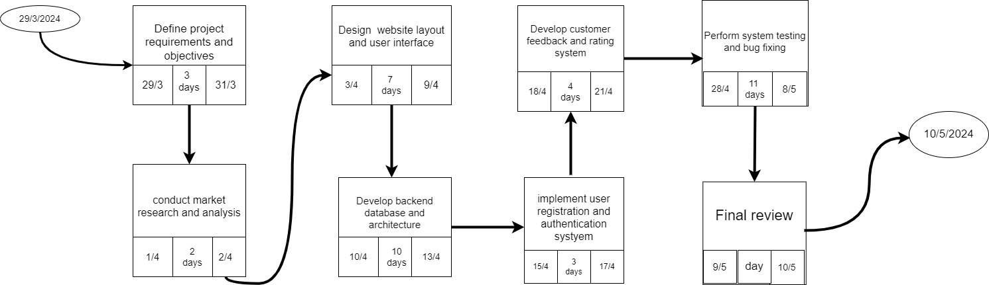

5 **FEASIBILITY STUDY**

**Risk Assessment:-**

**Risk Identification :**

**1- Website breach and theft of customer data.**

**2- Service interruption due to technical issues.**

**3- Non-compliance with personal data protection laws.**

**4- Electronic forgery and fraud.**

**5- Delay in delivery due to supply chain issues.**

**Risk Prioritization:**

**1- Website breach and theft of customer data:**

**\* High priority due to its potential impact on trust, legal repercussions, and reputation.**

**2- Non-compliance with personal data protection laws:**

**\* Also high priority because of severe legal consequences and reputation damage.**

**3- Electronic forgery and fraud:**

**\* Ranks high to medium due to potential financial losses and legal ramifications.**

**4- Service interruption due to technical issues:**

**\* Considered a medium priority as it can disrupt operations and affect customer satisfaction.**

**5- Delay in delivery due to supply chain issues:**

**\* Lower priority as it may not directly threaten data security or legal compliance.**

**Risk Mitigation:**

**1- Website breach and theft of customer data:**

**\* Implement robust cybersecurity measures, such as encryption and firewalls.**

**\* Conduct penetration testing and security audits.**

**2- Service interruption due to technical issues:**

**\* Regularly maintain and update IT infrastructure and development a backup plan.**

**3- Non-compliance with personal data protection laws:**

**\* Implement strong data protection policies and procedures.**

**\* Conduct regular audits to ensure adherence to data protection laws.**

**4- Electronic forgery and fraud:**

**\* Monitor financial transactions and account activities for suspicious behavior.**

**\* Use encryption for sensitive data transmission.**

**5- Delay in delivery due to supply chain issues:**

**\* Diversify suppliers and develop contingency plans to minimize delivery delays.**

**6 Tools**

Text Editor or IDE: such as Visual Studio Code

Database Management System (DBMS)

**Architecture**

Server Infrastructure

Storage Devices

Tools Backup and Disaster Recovery